**Names:Ishimwe Gulenne GulenneID:23177**

# Course: web technology And internet

* + Mandatory for the users regardless of their positions to have password for (**security)** purposes Candidates can vote for other candidates which are on the positions they are not electing for.
  + There shall be a page that displays candidate.
  + Users shall only register their vote other operations shall be done by the administrator.
  + System should ensure that the registered Student ID is an existing valid ID of AUCA students
  + No candidate is allowed to access his opponents account, same for voters (Security)
  + Mandatory for candidates to upload their profiles and their objectives.
  + System should be maintainable for making changes according to the users’ additional requirements (**Maintainability**)
  + Should store the results in the database.
  + System should enable users to search

System should be Available 24hours in 7 days a week (**Availability**)

**Purpose of the project**

Purpose of the project is to provide equal chances of voting for their preferred candidates Auca students to and at the same time making it easy to access voting. Students at Masoro campus had a high chance of voting than the one at Gishushu because it is the place where voting took place.so the system shall solve this problem by provide equal chances of voting for their leader students for both students at Masoro and Gishushu campus.

**scope of the project: for the user part he /she can only vote and register their vote but cannot view update or delete these functionality are only and only accessed by the administrator.**

deadlines:-may

**resources used of the project**

* Spring initializer
* MySQL driver
* IntelliJ editor

# 7.DATABASEDESIGN

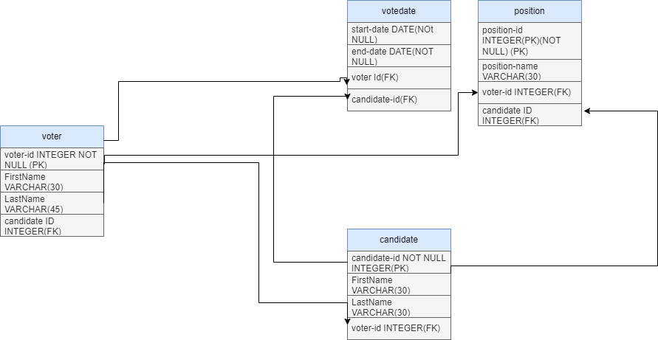

**NB:for the user part he /she can only vote and register their vote but cannot view update or delete these functionality are only and only accessed by the administrator.**

c

**Technical Documentation**

**Technologies used**

* Spring data Jpa
* Thyme leaf
* Spring security
* Spring web
* MySQL driver

**Controller part used for linking the view and the model part according to the users request**

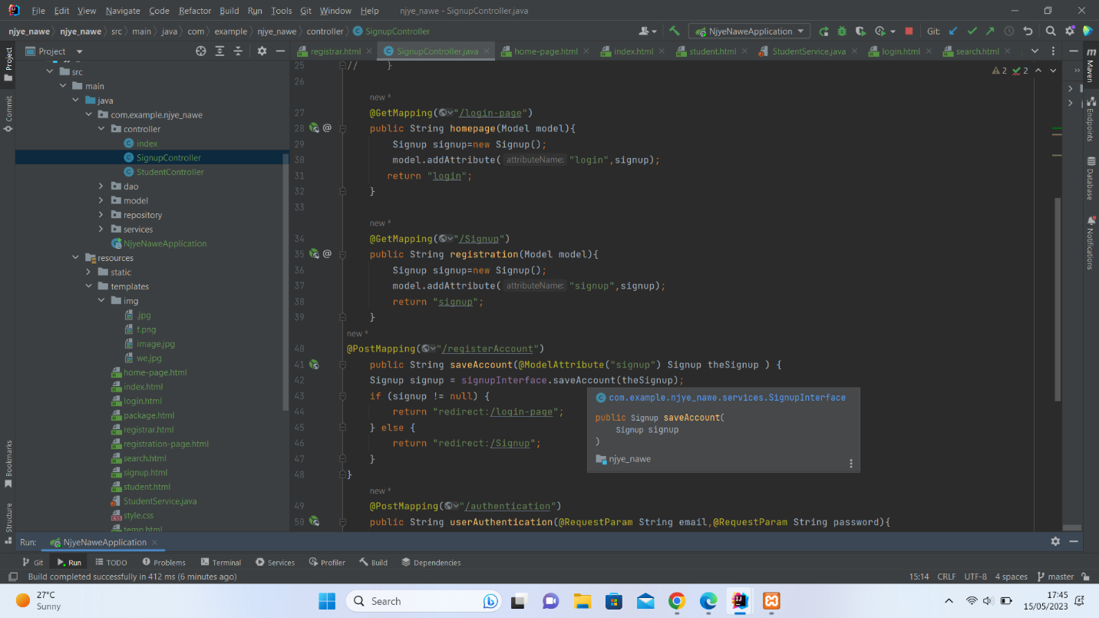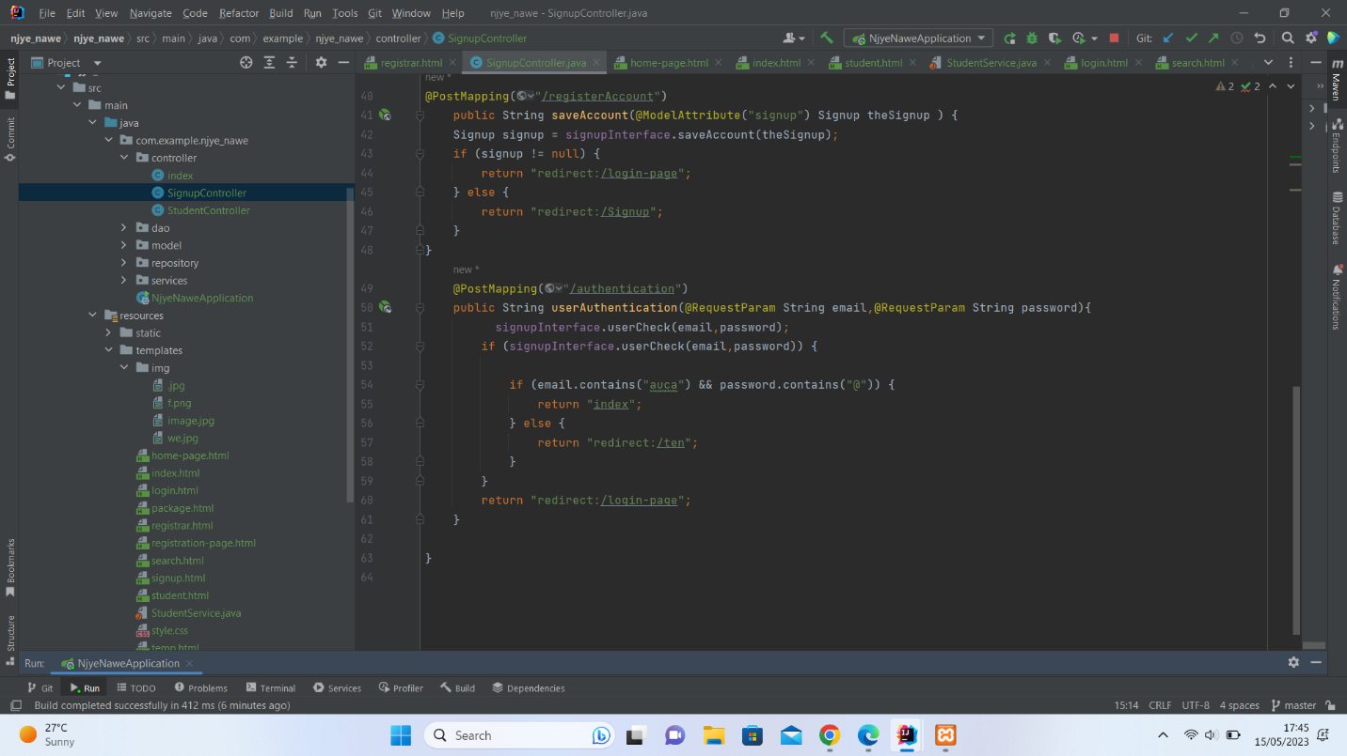

**Model part**

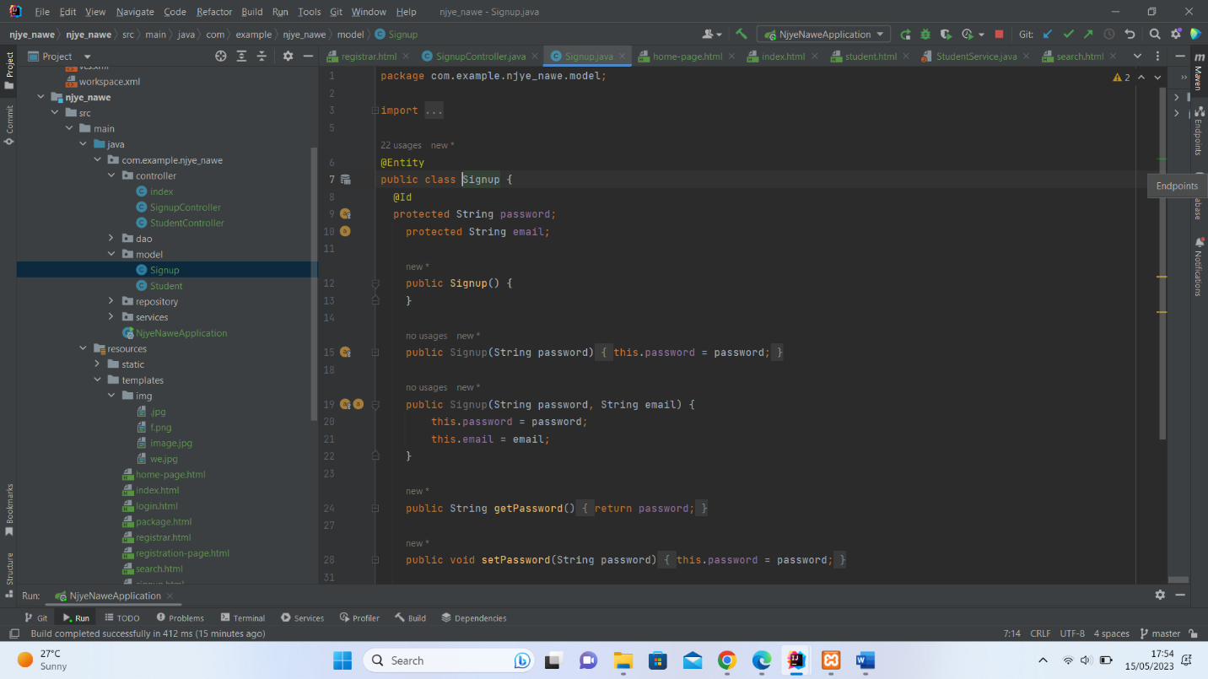

**APPLICATION PROPERTIES**

Where we link our data to the database

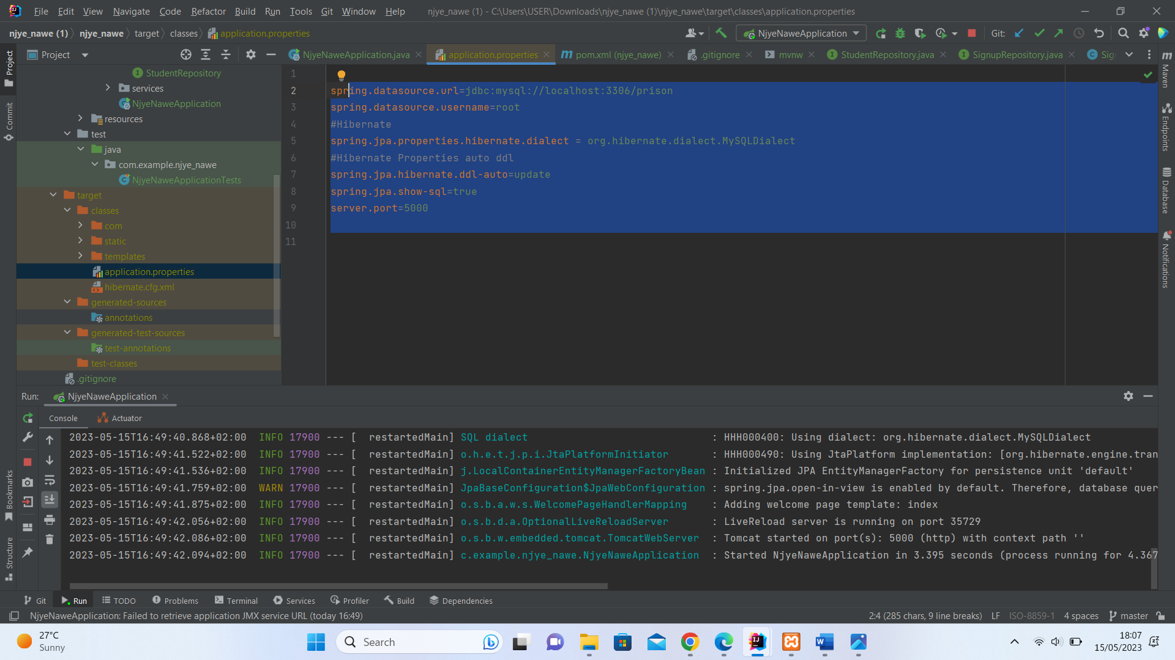

**Service layer**

Where all the CRUD operation take place**.**

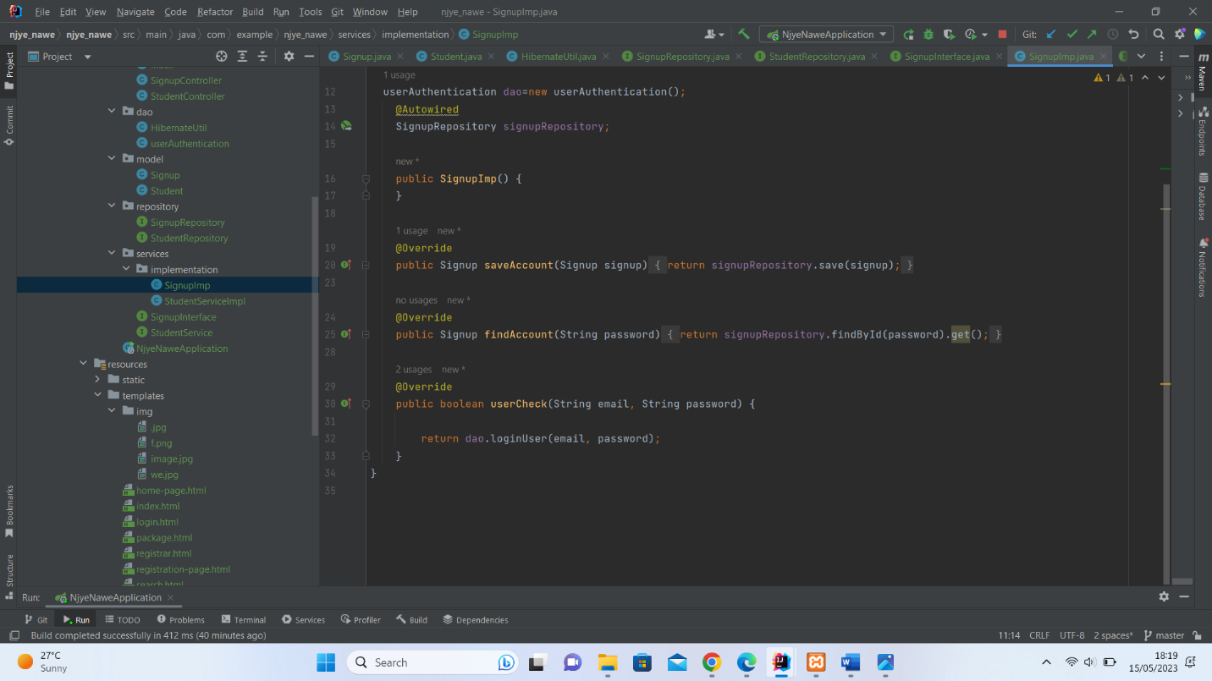

the view layer ,the layer used to interact with the user usually known as the user interface.

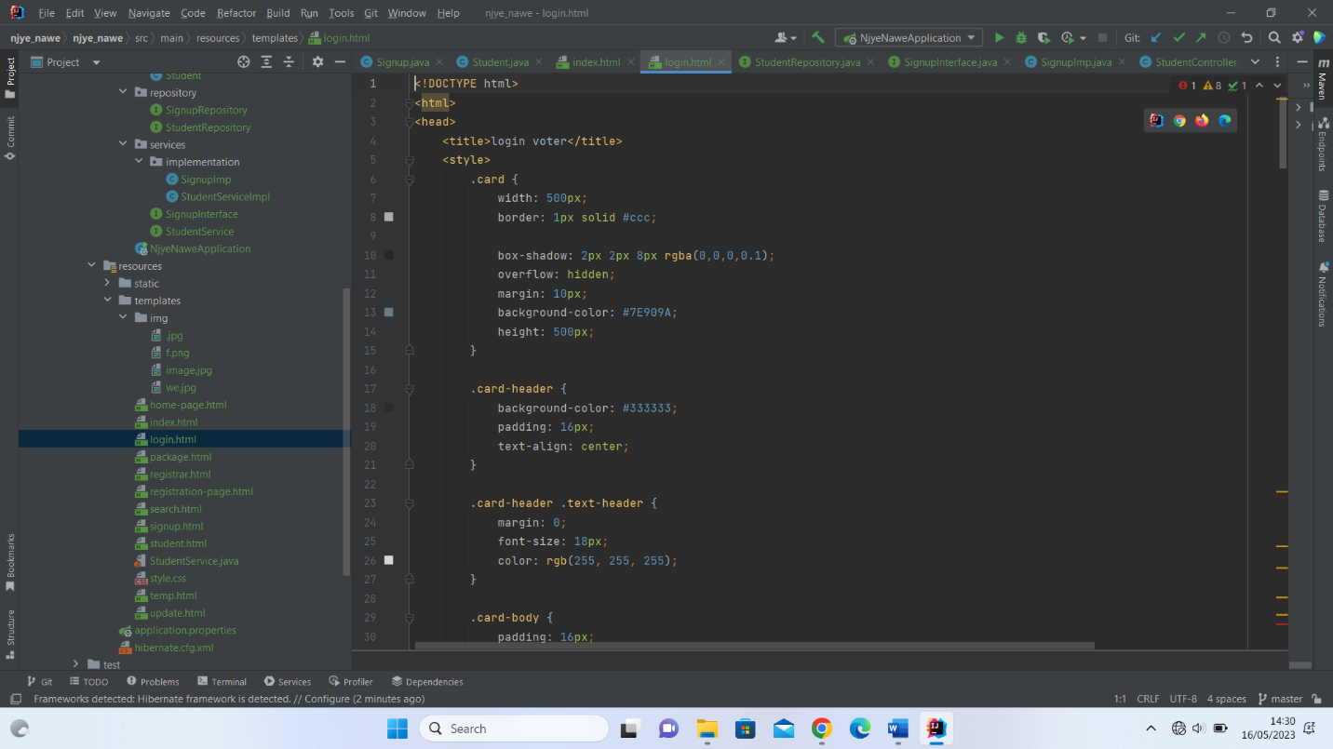

Authentication to check if we have the use in our database.

